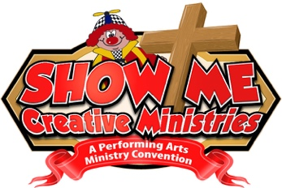

Show Me Arts & Ministry
One Form Per Attendee Please
2023 Registration includes admission to all educational workshops, general sessions,
exciting performances, clown store, great networking, and banquet dinner!

Name_____________________________________________ (Please Print)
Address _______________________________________
City____________________ State_____ Zip _________
Email (needed for confirmation) ___________________________________
Phone ________________________________________

*Groups of 5-9 save $5 each - Groups of 10 or more save $10 each if preregistered at same time.
- Register before October 1st $110
- Register after October 1st $120
- Register at the Door $130
Group or Alley Name ________________________

Junior Joey (8-15) Registration - This is a Saturday one day event.
- Register before October 1st $70
- Register after October 1st $75
- Register at the Door $90
*Junior Joey's MUST send the medical release form (available on website) & be 8.
*Junior Joey's MUST be with an adult at all times. Children under 8 are NOT ALLOWED in conference classes.

Thursday Intensives
- Balloon Décor $30
- Puppet Construction & Performance $30 (supplies paid at door)
- Face Painting For Fun & Profit (bring your supplies or kits for sale at door) $30
- Pediatric, Nursing Home and Veteran Clowning $30

Friday Intensives
- Children’s Ministry Extravaganza! $30
- Advanced Puppet Making $30 (supplies paid at door)
- Twisters University (bring your balloons!) $30
- Presenting the Gospel with Magic $30

Thursday & Friday Intensives (Save $10 register for both days)
- Thursday & Friday $50

Extras
- Additional Banquet & Show $35
- Conference 8 X 10 Group Photo $10
- Scholarship Fund Donation $ ______

Show Me Tee Shirt $20
S M L XL 2X 3X 4X (circle size)

Paid by Paypal - Yes No (circle one)
Paid by Check #_________ Total $_________
*Cancellation Policy: 30 days before conference 100% payment refund - Less than 30 days Roll over to 2022.
*Questions? Call Steve Kissell at: 757-615-8355 FamilyEntertainers@gmail.com
www.ShowMeArtsMinistry.com
Please Make Checks Payable To: Steve Kissell: 5531 Botanical Drive Virginia Beach, VA 23455

